Pamela De Santis – English II, LM – Task 2– March 30, 2009
OK
Correct this student’s answer to a question on an imaginary exam.
Very thoughtful of you, to have reproduced the original text. Thank you.
Which Englishes have “norm providing” status?
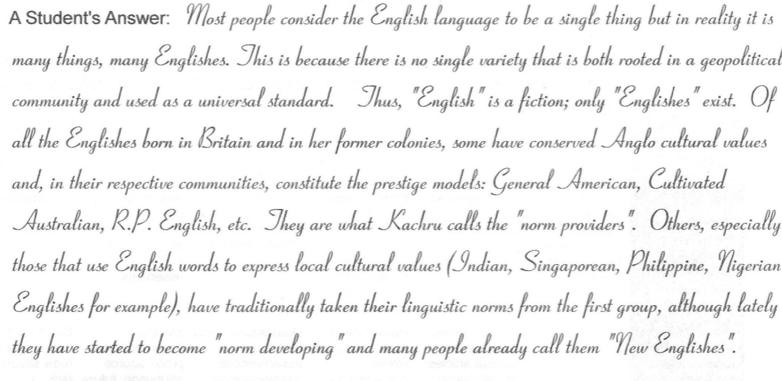
What should the student have written to accommodate better to her teacher’s Anglo mentality?
Which Englishes have “norm providing” status?
According to Kachru (1992: 356), who divides World the Englishes of the world [THEORETICALLY YOU COULD SAY “WORLD ENGLISHES”, NO PROBLEM, BUT BUTLER AND MacARTHUR MAKE THE DISTINCTION BETWEEN WORLD ENGLISH AND WORLD ENGLISHES AND SO, IF YOU DON'T WANT TO ADOPT THEIR VIEWPOINT, AVOID THE EXPRESSION AND USE THE LOCUTION “ENGLISHES OF THE WORLD. SEE HERE ] into three concentric circles (Inner, Outer, Expanding), Englishes that have ‘norm providing’ status are General American, Cultivated Australian, R.P. British English, New Zealand English, Irish English, Canadian English, South African English and they fall into the first circle, the ‘Inner circle’. This means that English language norms are WERE ORIGINALLY developed in their respective countries and English is the first language. According to Kandiah (1998), they also may called ‘Older Englishes’.[ACTUALLY, WITH THE EXCEPTION OF ENGLAND, THE ANGLO-DERIVED NORMS WERE NOT DEVELOPED IN THEIR RESPECTIVE COUNTRIES BUT RATHER TRANSPLANTED THERE, WHERE THEY EVOLVED DIFFERENTLY. INDEED, IN THE CASE OF IRISH ENGLISH ONE CAN SPEAK OF CREOLIZATION.]
The second circle, the ‘Outer circle’, is made up of Englishes that have ‘norm developing’ status, such as Indian English, Nigerian English, Philippines English, etc., which have become institutionalised and they are developing their own standards. These English varieties are not !!! ONE OF the official languageS, but are AND ARE ALSO important for historical reasons (British Empire) and play a part in the nation’s institutions. They also may called ‘New Englishes’.
The third, and the last circle, the ‘Expanding circle’, is made up of Englishes that have ‘norm dependent’ status, that is, they are regarded as ‘performance’ varieties without any official status and (ARE) therefore dependent on the standards set by native speakers in the Inner Circle. This circle includes much of the rest of the world’s countries, in which the English is a foreign language or lingua franca or it is employed for specific and limited purpose (business, learning, etc.).

According to this categorization, it becomeS evident that we can’t talk about a unique kind of English which is spoken in many different partS of the world, but rather we must talk about of different varieties of English that have a specific status in reference to their use in a particular country.

The following figure sumS up the division of Kachru’s World Englishes:

Expanding
circle

NORM DEPENDENT:
China, Japan, Italy, Russia, Egypt, etc.

NORM DEVELOPING:
Indian English, Nigerian English, Philippines English
Jamaican English, etc.
NORM PROVIDING: General American, Australian, R.P. British English, New Zealand English, Irish English, Canadian English, South African English
Outer circle
Inner circle

See http://www.routledge.com/rcenters/linguistics/pdf/we.pdf
See www.languagemuseum.org/menu/WorldEnglishesOxford&Jain.ppt

