COMPARISON USING HOFSTEDE'S DIMENSIONS
PDI (Power Distance Index) - the PDI score relates to the degree of equality or inequality between people in a country's society. A high PDI score indicates that inequalities of power and wealth exist in a country where as in low scoring countries there is more social equality. For tips on how to communicate and interact with people from the target country please visit Power Distance.
IDV (Individualism) - the individualism score focuses on the degree to which a culture values and reinforces the importance of the individual as opposed to the group. A high scoring country will view individuality and individual rights as critical. Low scoring countries will value the group, i.e. family, tribe, etc. For tips on how to communicate and interact with people from the target country please visit Individualism.
MAS (Masculinity) - masculinity focuses on the degree to which a culture reinforces the traditional role of males vs females. A high scoring country will have a more accute degree of gender differentiation whereas in low scoring countries there is less differentiation and discrimination between genders. For tips on how to communicate and interact with people from the target country please visit Masculinity.
VAI (Uncertainty Avoidance) - uncertainty avoidance looks at the level of tolerance for uncertainty and ambiguity within a culture. Cultures with a high uncertainty avoidance score will have a low tolerance for uncertainty and ambiguity. This is seen through it being a more rule-oriented society that institutes laws, rules, regulations. A low scoring country is less concerned about ambiguity and uncertainty and is less rule-oriented, more ready to accept change, consider new ideas and take more and greater risks. For tips on how to communicate and interact with people from the target country please visit Uncertainty Avoidance.

http://www.kwintessential.co.uk/intercultural-business-communication/tool.php?culture1=28&culture2=26

COMPARISON  USING HOFSTEDE'S DIMENSIONS  BETWEEN  ITALY  AND  AUSTRALIA  IRELAND  JAMAICA  THE UNITED KINGDOM  THE UNITED STATES | 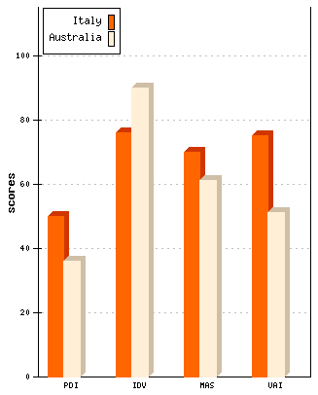 | 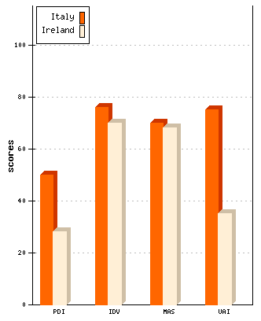
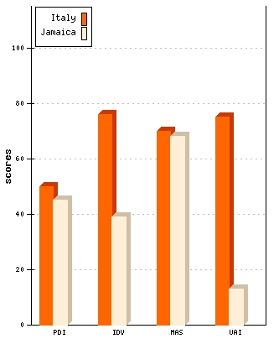 | 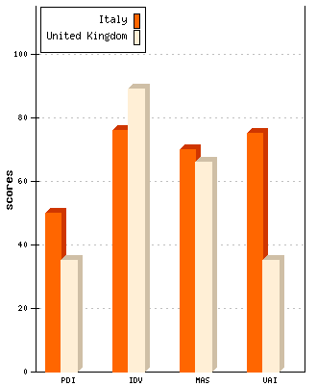 | 