University of Rome III - Degree in Languages & International Communication - Convener: Patrick Boylan - Academic year 2005-2006
Describe the key gestures you observed (Put the hypothesized meaning between parentheses.)

Italian comic Robert Benigi  on TV show Tutto Benigni  © RAI Television, 1996 | 1. 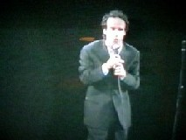 | 2, 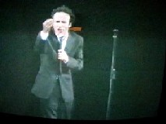 | 3,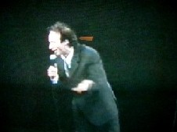
Words (translated from the original Italian),  other sounds, pauses | Gasp (surprise)  “You say I'm guilty?” | “What do you mean?”  “Aoh!?” (defiant summons) | “I'm innocent!”  Long pause (3”) (baiting)
Rhythm,  intonation  . | Low tone, further sharp drop in intonation on “guilty” (incredulity) | Strident exclamatory tone, accelerated rhythm, prolongation of “Aoh” | Slow, deliberate cadence; “inn-” drawn out, said with low key exclamatory tone.
Gestures, other  hand movements | Clasped hands (request for indulgence). | Pursed hand. (request for clarification) | Left arm held out laterally, palm up (nothing to hide)
Facial expressions,  head movements | Eyes wide open, mouth gaping, head held up.  (incredulity) | Frowning eyebrows, snarling mouth (defiant incredulity) | Open smile (sincerity, bid for acknowledgement), head down and gaze up (child-like ingenuousness)
Posture,  body movement | Shoulders hunched, slight inclination,  (awaiting judgement humbly) | Boxer stance (defensive attitude), arm held out in front (warning) | Erect but strongly inclined forward (self-consignment: I'm yours!)
Adapted from I. Poggi, “Multimodal Score: an ANVILtm Based Annotation Scheme for Multimodal Audio-Video Analysis”, www.istc.cnr.it, 2003 and from D. Alalov, “La multimodalità della comunicazione e l’analisi culturale comparativa”, tesi di laurea, Università Roma Tre, Rome, 2004.

Englishman interviewed outside the University of Amsterdam  © PICTURE project, 2006 | 1. 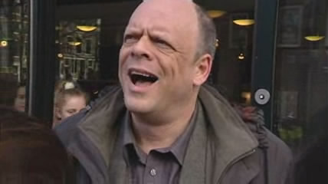 | 2. 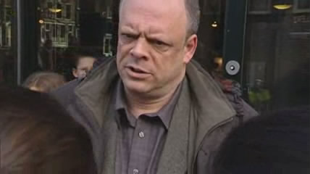 | 3,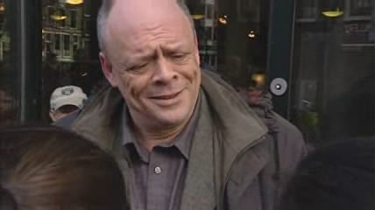
Words,
other sounds, pauses
Rhythm,
intonation
.
Gestures, other
hand movements
Facial expressions,
head movements
Posture,
body movement

