Granada Management

updated by George Simons 20 January 2008
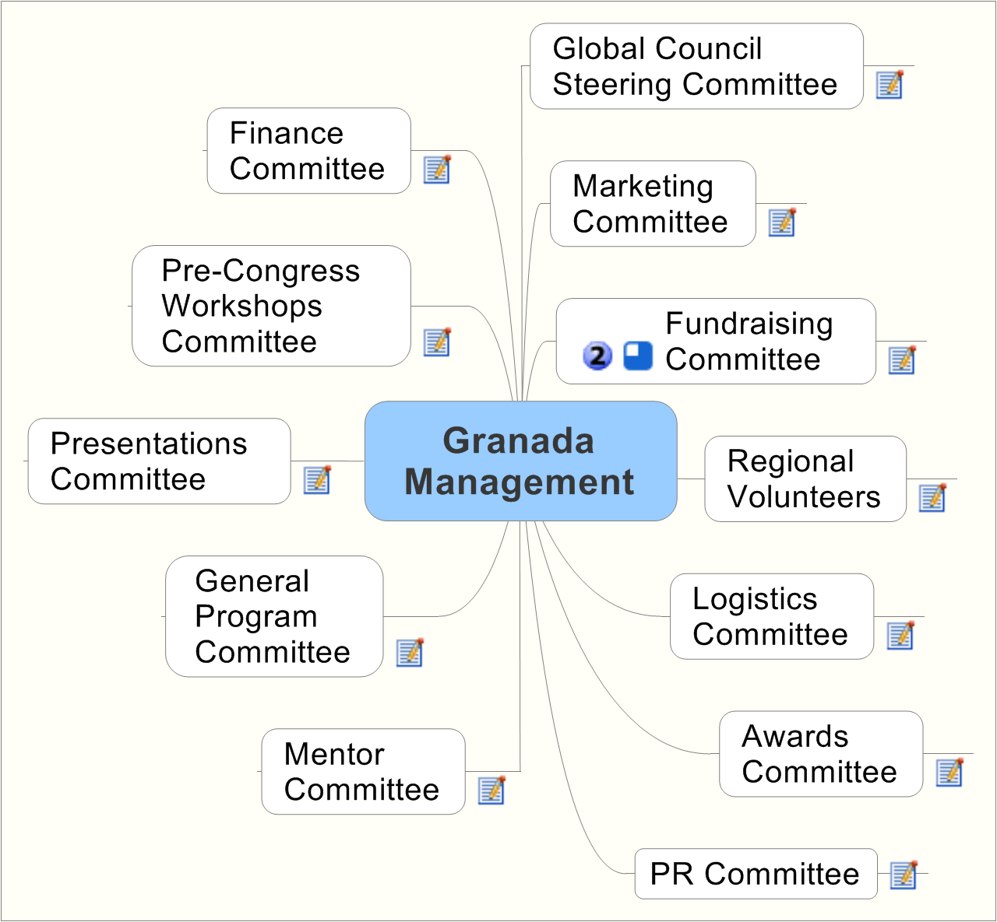

- Global Council Steering Committee

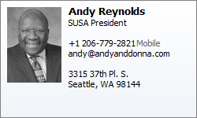 | andy@andyanddonna.com
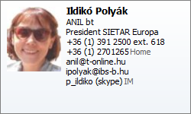 | anil@t-online.hum ipolyak@ibs- b.hu
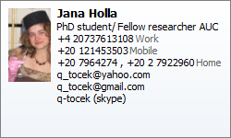 | q_tocek@yahoo.com

- Marketing Committee

Chair pro tem until March 2008  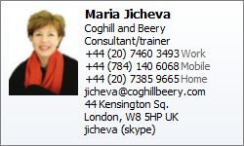 | jicheva@coghillbeery.com
Online Networking  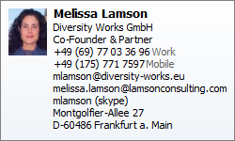 | mlamson@diversity-works.biz
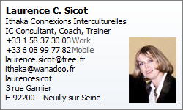 | laurence.sicot@free.fr
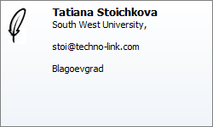 | stoi@techno-link.com
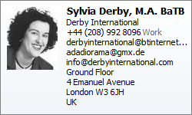 | info@derbyinternational.com
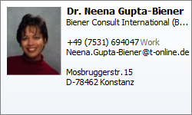 | Neena.Gupta-Biener@t-online.de
 | rwuebbeler@aol.com
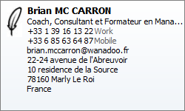 | brian.mccarron@wanadoo.fr
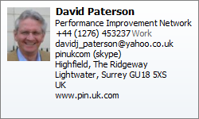 | davidj_paterson@yahoo.co.uk
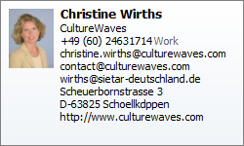 | christine.wirths@culturewaves.com
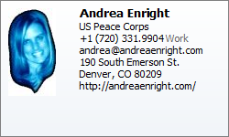 | andrea@andreaenright.com
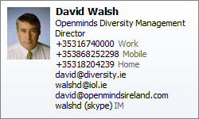 | david@diversity.ie
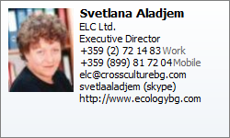 | elc@crossculturebg.com
 | efm@crossing-cultures.com
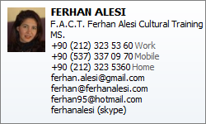 | ferhan.alesi@gmail.com
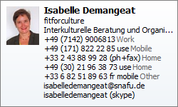 | isabelledemangeat@snafu.de

- Fundraising Committee

Fundraising  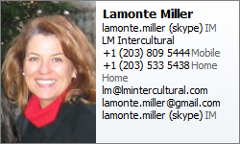 | lm@lmintercultural.com
Fundraising (starting Feb 08 )  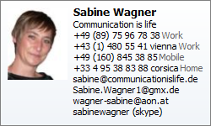 | sabine@communicationislife.de

- Regional Volunteers

Japan  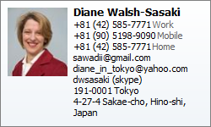 | sawadii@gmail.com
New Zealand  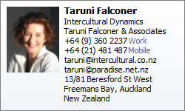 | taruni@intercultural.co.nz
Young SIETAR | q_tocek@yahoo.com jana@aucegypt.edu, janaholla@hotmail.com,
Students and universities  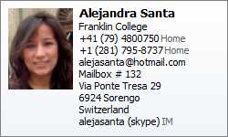 | alejasanta@hotmail.com

Spain  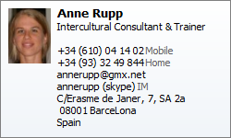 | annerupp@gmx.net
China   | donny_huang@4stones.net
China  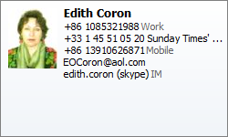 | EOCoron@aol.com
France Midi  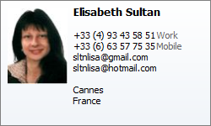 | sltnlisa@hotmail.com

Brazil   | ica@infolink.com.br
Africa (Ethiopia)  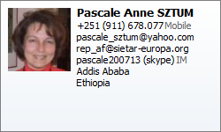 | pascale_sztum@yahoo.com
Denmark  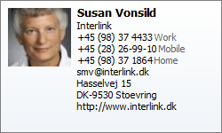 | smv@interlink.dk
France (Paris)  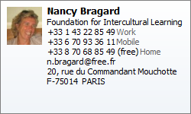 | n.bragard@free.fr

USA Marketing Team
Southwest-OK, TX   | kelli@treasureculture.biz  travelstar13@aol.com
Southeast   | mariagill@yahoo.com
 | BridgingCultures@aol.com
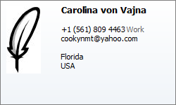 | cookynmt@yahoo.com

- Logistics Committee
CIA team  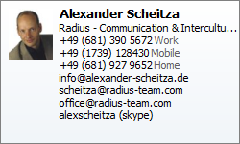 | scheitza@radius-team.com
Logistic info  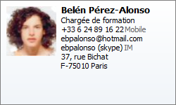 | ebpalonso@hotmail.com
Low cost housing | efm@crossing-cultures.com
Ecological concerns  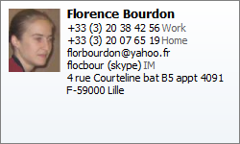 | florbourdon@yahoo.fr
Coordinator  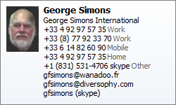 | gfsimons@wanadoo.fr
Co-coordinator  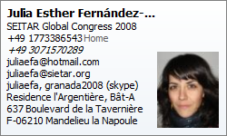 | juliaefa@sietar.org

- Awards Committee
Chair   | Kate@culturosity.com

- PR Committee

Chair  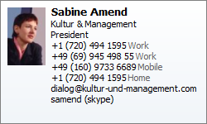 | dialog@kultur-und-management.com
No longer active. Summer intern 2007  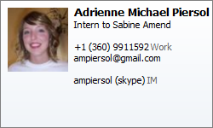 | ampiersol@gmail.com

- Mentor Committee
 | emerth@yahoo.com

- General Program Committee
Coordinator pro tem | gfsimons@wanadoo.fr
Co-coordinator | juliaefa@sietar.org
CIA team | scheitza@radius-team.com
Youth | q_tocek@gmail.com
NGO Sector  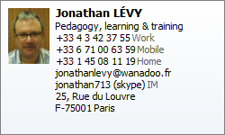 | jonathanlevy@wanadoo.fr
Film Festival  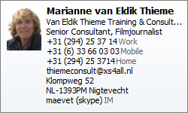 | thiemeconsult@xs4all,nl
Muslim Women  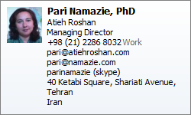 | pari@atiehroshan.com
Africa | pascale_sztum@yahoo.com

- Presentations Committee
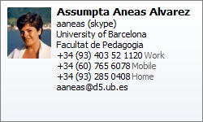 | aaneas@d5.ub.es  aaneas@hotmail.com
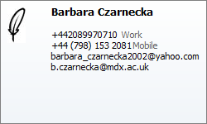 | barbara_czarnecka2002@yahoo.com
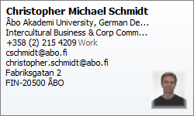 | cschmidt@abo.fi
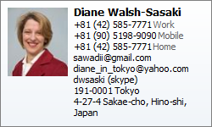 | sawadii@gmail.com
Presentations Co-Chair   | elouie@whitworth.edu
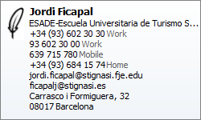 | jordi.ficapal@stignasi.fje.edu
Presentations Co-Chair   | mdpusch@pobox.com
 | jicheva@coghillbeery.com
 | mrabotin@egleadership.com
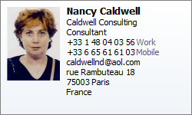 | caldwellnd@aol.com
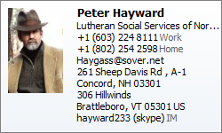 | Haygass@sover.net
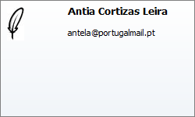 | antela@portugalmail.pt
 | shirley@asialink.se
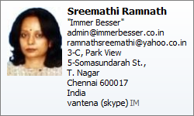 | ramnathsreemathi@yahoo.co.in  admin@immerbesser.co.in

- Pre-Congress Workshops Committee

Chair  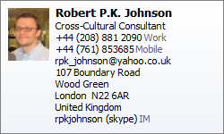 | rpk_johnson@yahoo.co.uk
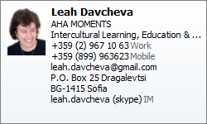 | leah.davcheva@gmail.com
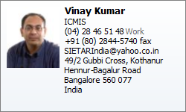 | vinay@icmis.org

- Finance Committee
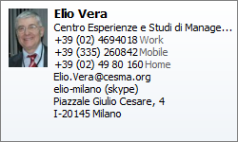 | Elio.Vera@cesma.org
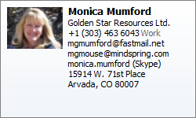 | mgmumford@fastmail.net

